Hosting a Static Website on AWS s3

1)First Create general purpose s3 bucket

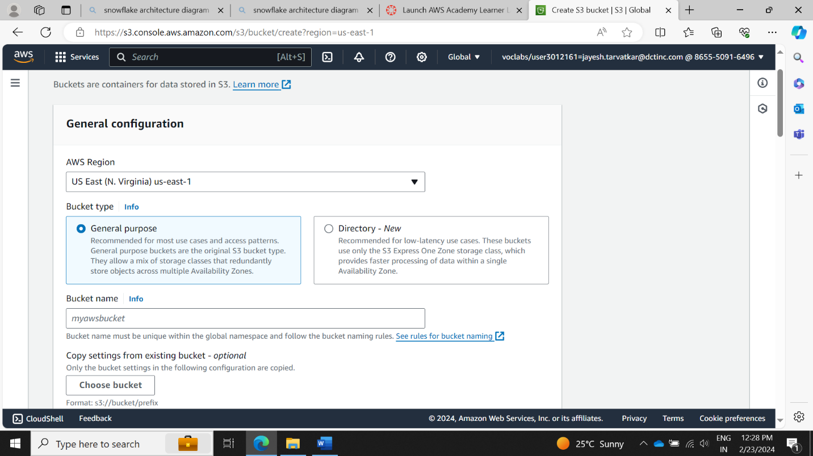

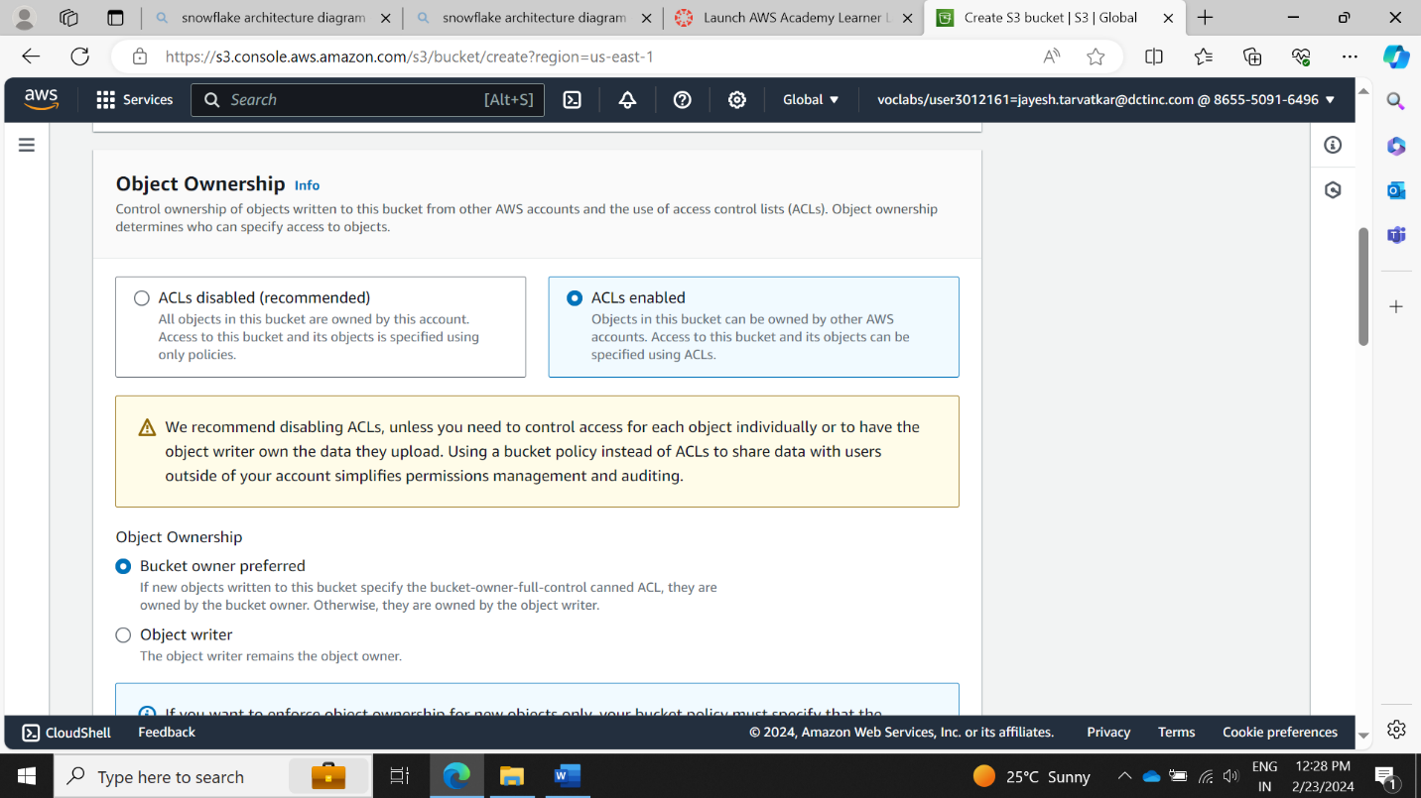

Add the .html files inside the bucket

Setup general configuration,select static webhosting and enable it

Edit the policy

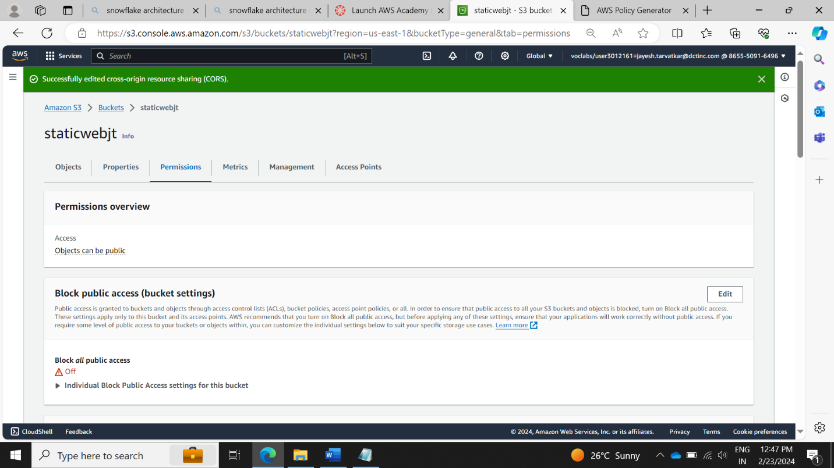

Paste the bucket policy

Now the website link is visible :

Now open the link, and our website is visible :

